**Group Chat Application**

**The chat application is between multiple clients and the interaction messages are stored in the MongoDB.**

**Requirements:**

* HTML, Bootstrap(CSS and JS), JQuery
* NodeJS, ExpressJS,
* HTTP, SocketIO, Body Parser,
* Mongoose, and MongoDB.

Installations

* Install nodejs.
* To create the package.json run the command

***npm init***

If needed, set the names for the package.json, description and repositories.

* Once the package.json is created. Install other modules.
  + Install mongoose, and mongodb as

***npm install –g –s mongoose mongodb***

* + Install socketio, body-parser, http, express as

***npm install –g –s socketio body-parser http express***

* Once all the packages are installed successfully, check the packages.json file for the version.
  + Set the “***start***” under scripts as node ***server.js***

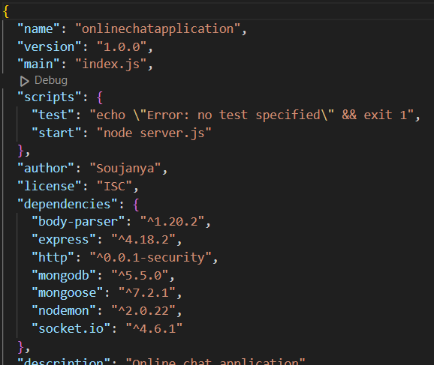

* Now under the current project,
  + Add the *server.js* and write the logic to import the required modules.
  + Write the logic to connect the socket, mongoose and mongodb.
  + Write the logic
    - Set the communications between clients and server through the socket.
    - Read the messages from the front end and store them in the mongodb using express.
    - Use body-parser to parse the data from the front end.
    - Use http, to listen the socket.
  + Add a *index.html* file.
    - Design the front end.
    - Also, add the script to get the messages and display the messages to all the clients.